Quarch Technology Ltd

AN-024

Application Note

QPS Window Averaging Example

For use with:
HD PPM and PAM
QTL1999 / QTL1995 / QTL2312

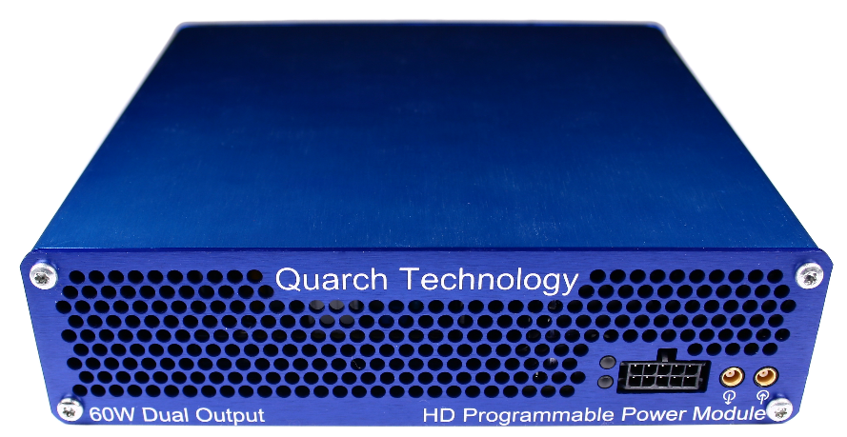

Change History
1.0 | October 2021 | Initial Release

Contents
Change History 2
Introduction 4
WARNING Error! Bookmark not defined.
Requirements Error! Bookmark not defined.
Installation Error! Bookmark not defined.
Equipment Setup Error! Bookmark not defined.
Calibration Process Error! Bookmark not defined.
Power Module Selection Error! Bookmark not defined.
Select Action Error! Bookmark not defined.
Select Calibration Instrument Error! Bookmark not defined.
Calibration Sections Error! Bookmark not defined.
Switch Requests Error! Bookmark not defined.
Calibration Output Error! Bookmark not defined.

Introduction
Post processing of captured data can be very useful to get the exact results you need for comparison.
This simple example implements a sliding average window over a data set, looking for a worst-case power measurement. The input data is in CSV form, exported from QPS (Though it will work with any similar data set).
The output is a single value for the worst case average found in any window. This is a common way to find the peak power consumed by a device, while excluding brief noise spikes.
The window size can be set to achieve the result you need. A short window of 100uS could be used to reject noise and brief spikes, while a window of 100mS to 1 second might be useful for considering the overall view of a workload.
The process time depends on the CSV file size. A 26GB CSV file in our test run took 10 minutes to process.
Note that this example does NOT require Quarch hardware to run, only the data captured from it previously.

Data for processing
First you need data to process. This can be dumped to file via automated capture using QIS or QPS, examples are here:
https://quarch.com/file/an-012-qis-python-control-of-power-modules/
https://quarch.com/file/an-015-automating-qps/
It can also be taken manually from QPS by exporting to CSV format, which is found in the File->Export menu.

Running the script
Run the supplied WindowAverageExample.py using python
> python WindowAverageExample.py
Ensure the test_data.csv file supplied is still present

Supply your own data
Simple switch out the path to the test data to supply your own
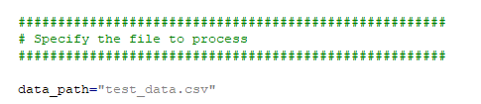
To run, you must ensure:
- Your window length is supplied in the same units as the CSV time column
- The column name to process is correct
- The CSV delimiter is correct for the CSV file format (normally a comma)

